Experiment 8
AIM: Develop Inventory Management Module using ADO.NET & CRUD Operations
Source: App_Start/RouteConfig.cs
Code:
using System;
using System.Collections.Generic;
using System.Linq;
using System.Web;
using System.Web.Mvc;
using System.Web.Routing;

namespace connecting_sql
{
public class RouteConfig
{
public static void RegisterRoutes(RouteCollection routes)
{
routes.IgnoreRoute("{resource}.axd/{*pathInfo}");

routes.MapRoute(
name: "Default",
url: "{controller}/{action}/{id}",
defaults: new { controller = "Products", action = "Index", id = UrlParameter.Optional }
);
}
}
}

Source: Controllers/ProductsController.cs

Code:

using System;
using System.Collections.Generic;
using System.Data.SqlClient;
using System.Web.Mvc;
using connecting_sql.Models;

namespace connecting_sql.Controllers
{
public class ProductsController : Controller
{
string cs = "Data Source=(localdb)\\MSSQLLocalDB;Initial Catalog=TestDB;Integrated Security=True";

public ActionResult Index()
{
List<Products> productList = new List<Products>();

using (SqlConnection con = new SqlConnection(cs))
{
string query = "SELECT * FROM Products";
SqlCommand cmd = new SqlCommand(query, con);
con.Open();
SqlDataReader rd = cmd.ExecuteReader();

while (rd.Read())
{
productList.Add(new Products
{
Id = Convert.ToInt32(rd["ProductId"]),
Name = rd["ProductName"].ToString(),
Quantity = Convert.ToInt32(rd["Quantity"]),
Price = Convert.ToSingle(rd["Price"])
});
}
}

return View("Home",productList);
}

public ActionResult Create()
{
return View();
}

[HttpPost]
public ActionResult Create(Products prod)
{
using (SqlConnection con = new SqlConnection(cs))
{

string query = "INSERT INTO Products (ProductName, Quantity, Price) VALUES (@ProductName, @Quantity, @Price)";
SqlCommand cmd = new SqlCommand(query, con);
cmd.Parameters.AddWithValue("@ProductName", prod.Name);
cmd.Parameters.AddWithValue("@Quantity", prod.Quantity);
cmd.Parameters.AddWithValue("@Price", prod.Price);

con.Open();
cmd.ExecuteNonQuery();
}

return RedirectToAction("Index");
}

public ActionResult Edit(int id)
{
Products prod = null;

using (SqlConnection con = new SqlConnection(cs))
{
string query = "SELECT * FROM Products WHERE ProductId = @ProductId";
SqlCommand cmd = new SqlCommand(query, con);
cmd.Parameters.AddWithValue("@ProductId", id);

con.Open();
SqlDataReader rd = cmd.ExecuteReader();

if (rd.Read())
{
prod = new Products
{
Id = Convert.ToInt32(rd["ProductId"]),
Name = rd["ProductName"].ToString(),
Quantity = Convert.ToInt32(rd["Quantity"]),
Price = Convert.ToSingle(rd["Price"])
};
}
}

if (prod == null)
{
return HttpNotFound();
}

return View(prod);
}

[HttpPost]
public ActionResult Edit(Products prod)
{
using (SqlConnection con = new SqlConnection(cs))
{
string query = "UPDATE Products SET ProductName = @ProductName, Quantity = @Quantity, Price = @Price WHERE ProductId = @ProductId";
SqlCommand cmd = new SqlCommand(query, con);
cmd.Parameters.AddWithValue("@ProductId", prod.Id);

cmd.Parameters.AddWithValue("@ProductName", prod.Name);
cmd.Parameters.AddWithValue("@Quantity", prod.Quantity);
cmd.Parameters.AddWithValue("@Price", prod.Price);

con.Open();
cmd.ExecuteNonQuery();
}

return RedirectToAction("Index");
}
[HttpPost]
public ActionResult Delete(int id)
{
using (SqlConnection con = new SqlConnection(cs))
{
string query = "DELETE FROM Products WHERE ProductId = @ProductId";
SqlCommand cmd = new SqlCommand(query, con);
cmd.Parameters.AddWithValue("@ProductId", id);

con.Open();
cmd.ExecuteNonQuery();
}

return RedirectToAction("Index");
}
}
}

Source: Models/Products.cs

Code:

using System;
using System.Collections.Generic;
using System.Linq;
using System.Web;

namespace connecting_sql.Models
{
public class Products
{
public int Id { get; set; }
public String Name { get; set; }
public int Quantity { get; set; }
public float Price { get; set; }
}
}

Source: Views/Products/Create.cshtml

Code:

@model connecting_sql.Models.Products

@{
ViewBag.Title = "Create Product";
}

<h2>Create Product</h2>

@using (Html.BeginForm())
{
@Html.AntiForgeryToken()

<div class="form-horizontal">
<hr />
@Html.ValidationSummary(true, "", new { @class = "text-danger" })

<div class="form-group">
@Html.LabelFor(model => model.Name, htmlAttributes: new { @class = "control-label col-md-2" })
<div class="col-md-10">
@Html.EditorFor(model => model.Name, new { htmlAttributes = new { @class = "form-control" } })
</div>
</div>

<div class="form-group">
@Html.LabelFor(model => model.Quantity, htmlAttributes: new { @class = "control-label col-md-2" })
<div class="col-md-10">
@Html.EditorFor(model => model.Quantity, new { htmlAttributes = new { @class = "form-control" } })
</div>

</div>

<div class="form-group">
@Html.LabelFor(model => model.Price, htmlAttributes: new { @class = "control-label col-md-2" })
<div class="col-md-10">
@Html.EditorFor(model => model.Price, new { htmlAttributes = new { @class = "form-control" } })
</div>
</div>

<div class="form-group" style="margin-top:15px;">
<div class="col-md-offset-2 col-md-10">
<input type="submit" value="Create" class="btn btn-success" />
@Html.ActionLink("Back to List", "Index", null, new { @class = "btn btn-secondary" })
</div>
</div>
</div>
}

Source: Views/Products/Edit.cshtml

Code:

@model connecting_sql.Models.Products

@{
ViewBag.Title = "Edit Product";
}

<h2>Edit Product</h2>

@using (Html.BeginForm())
{
@Html.AntiForgeryToken()

<div class="form-horizontal">
<hr />
@Html.ValidationSummary(true, "", new { @class = "text-danger" })
@Html.HiddenFor(model => model.Id)

<div class="form-group">
@Html.LabelFor(model => model.Name, htmlAttributes: new { @class = "control-label col-md-2" })
<div class="col-md-10">
@Html.EditorFor(model => model.Name, new { htmlAttributes = new { @class = "form-control" } })
</div>
</div>

<div class="form-group">
@Html.LabelFor(model => model.Quantity, htmlAttributes: new { @class = "control-label col-md-2" })
<div class="col-md-10">

@Html.EditorFor(model => model.Quantity, new { htmlAttributes = new { @class = "form-control" } })
</div>
</div>

<div class="form-group">
@Html.LabelFor(model => model.Price, htmlAttributes: new { @class = "control-label col-md-2" })
<div class="col-md-10">
@Html.EditorFor(model => model.Price, new { htmlAttributes = new { @class = "form-control" } })
</div>
</div>

<div class="form-group" style="margin-top:15px;">
<div class="col-md-offset-2 col-md-10">
<input type="submit" value="Save" class="btn btn-primary" />
@Html.ActionLink("Back to List", "Index", null, new { @class = "btn btn-secondary" })
</div>
</div>
</div>
}

Source: Views/Products/Home.cshtml

Code:
﻿
@model IEnumerable<connecting_sql.Models.Products>

@{
ViewBag.Title = "Product Inventory";
}

<h2>Product Inventory</h2>

<p>
@Html.ActionLink("Create New Product", "Create", null, new { @class = "btn btn-primary" })
</p>

<table class="table table-bordered table-striped">
<tr>
<th>@Html.DisplayNameFor(model => model.Name)</th>
<th>@Html.DisplayNameFor(model => model.Quantity)</th>
<th>@Html.DisplayNameFor(model => model.Price)</th>
<th>Actions</th>
</tr>

@foreach (var item in Model) {
<tr>
<td>@Html.DisplayFor(modelItem => item.Name)</td>
<td>@Html.DisplayFor(modelItem => item.Quantity)</td>
<td>@Html.DisplayFor(modelItem => item.Price)</td>
<td>
@Html.ActionLink("Edit", "Edit", new { id = item.Id })
@using (Html.BeginForm("Delete", "Products", new { id = item.Id }, FormMethod.Post, new { style = "display:inline;" }))

{<button type="submit" onclick="return confirm('Are you sure you want to delete this product?');">Delete</button>}
</td>

</tr>
}
</table>

Output:
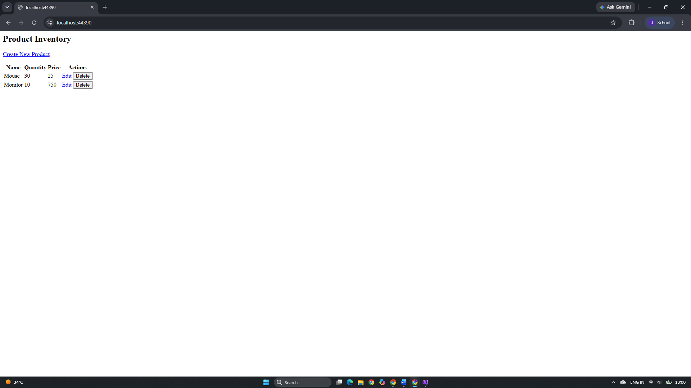

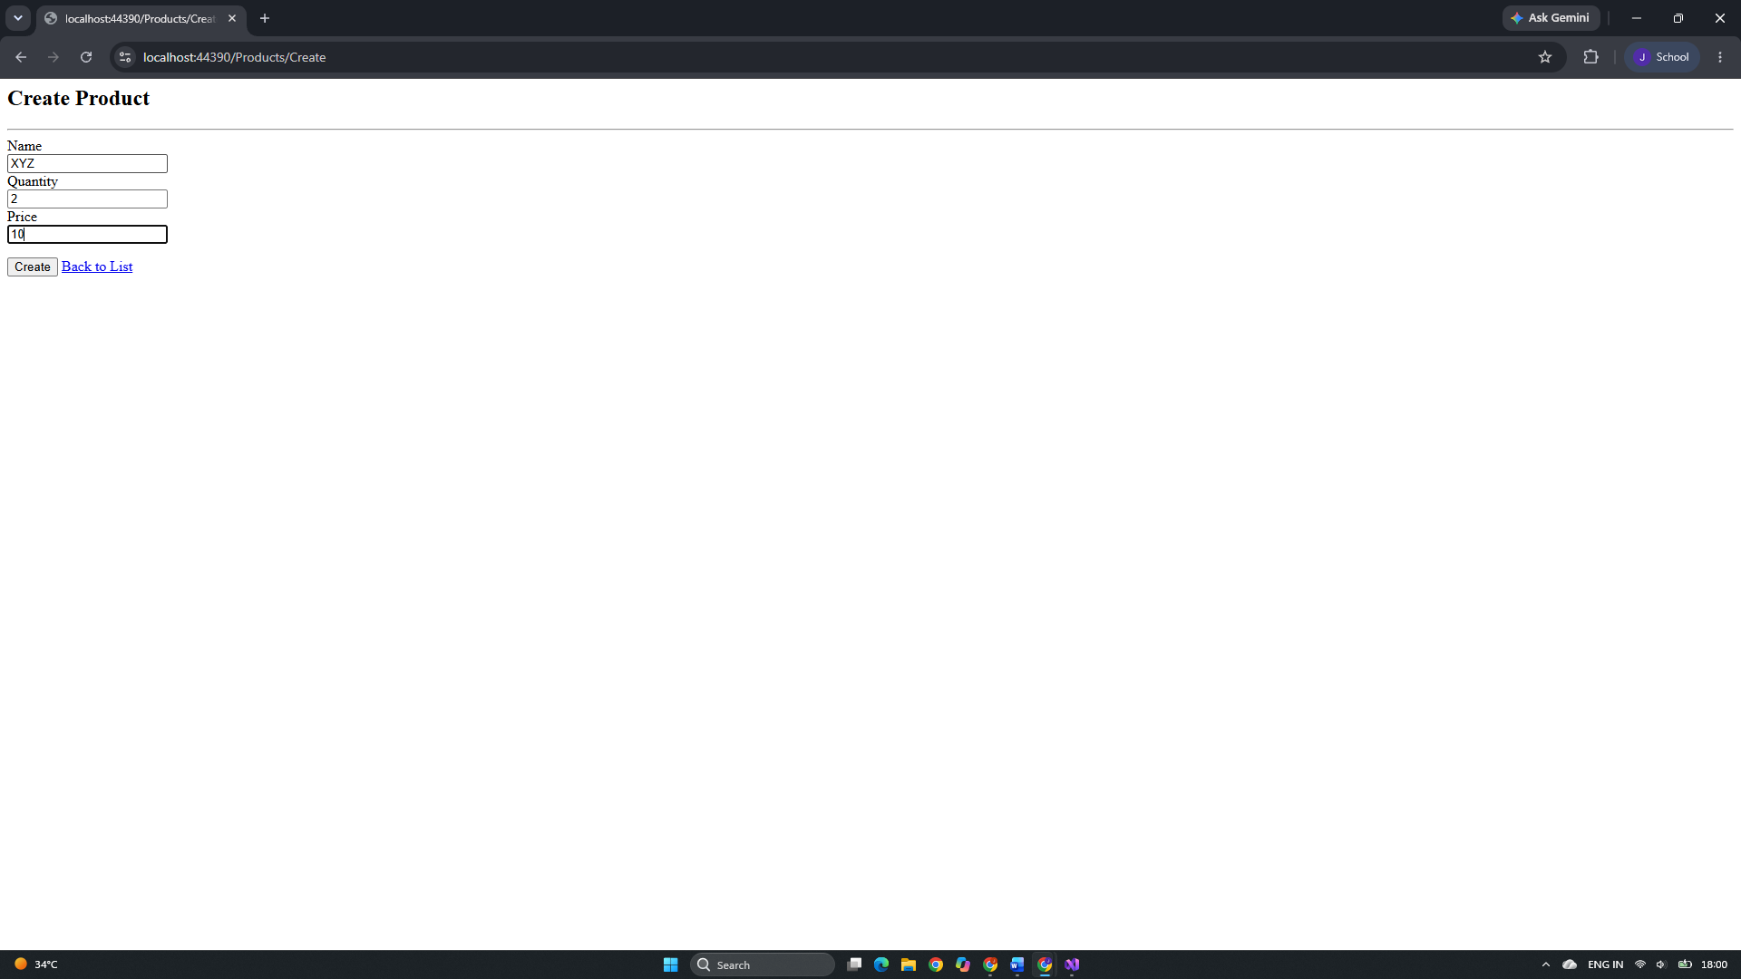

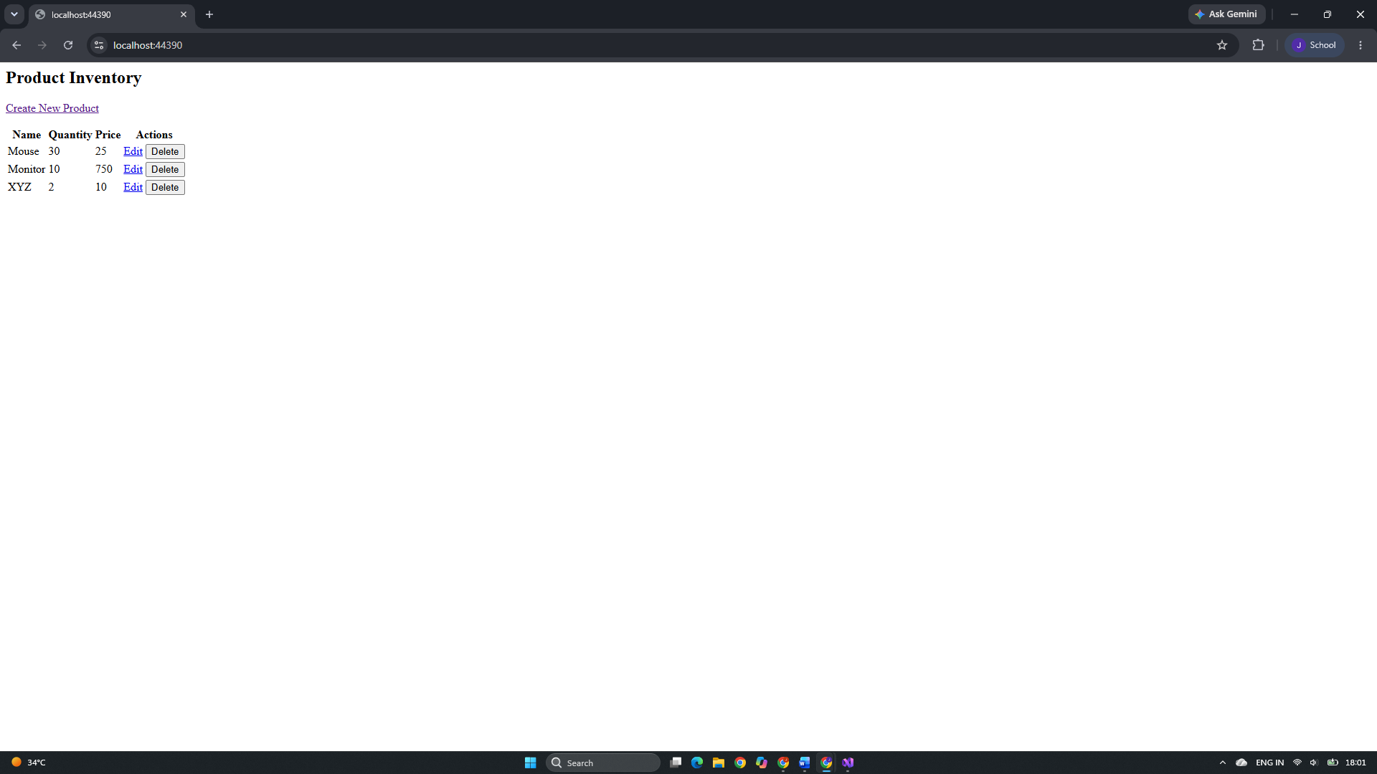
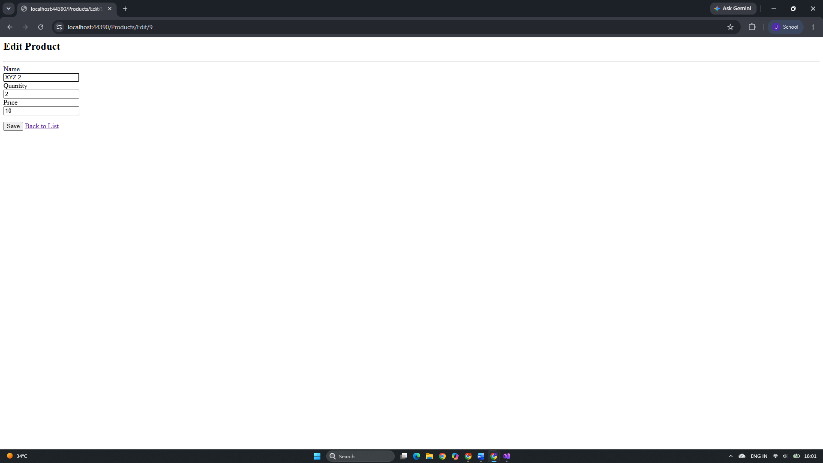

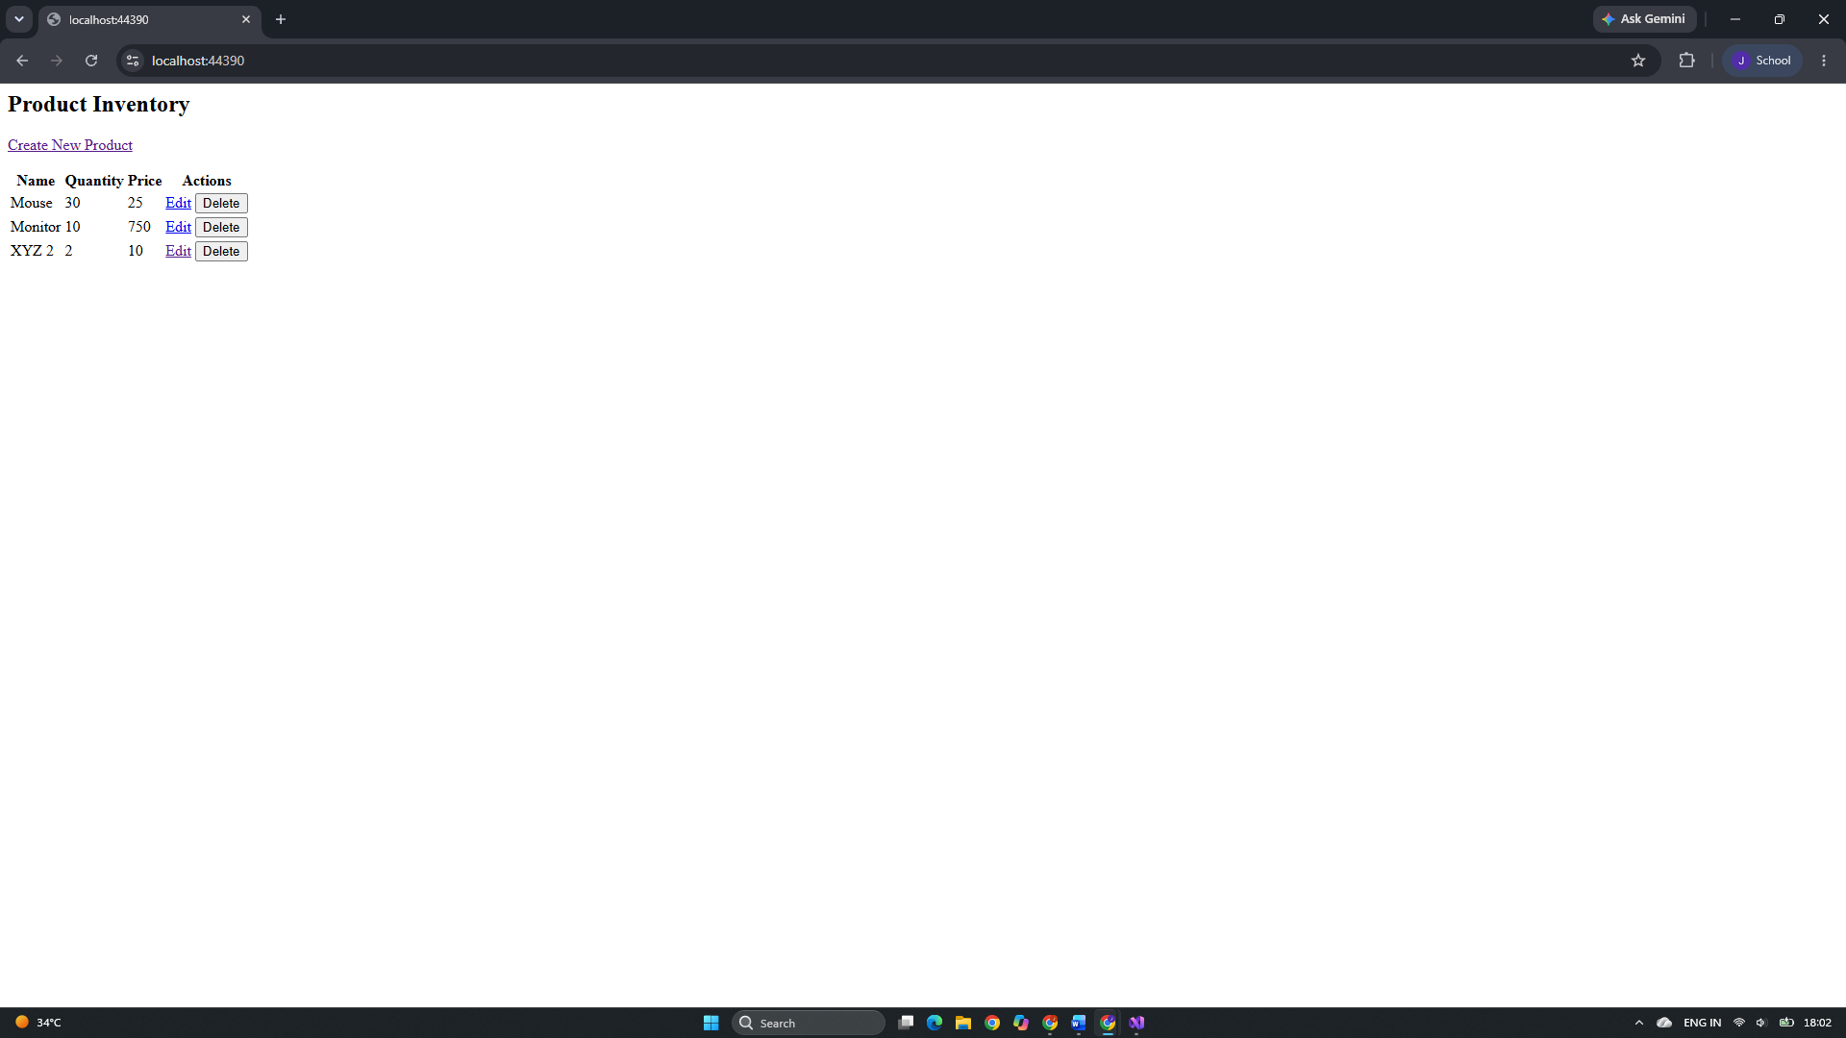
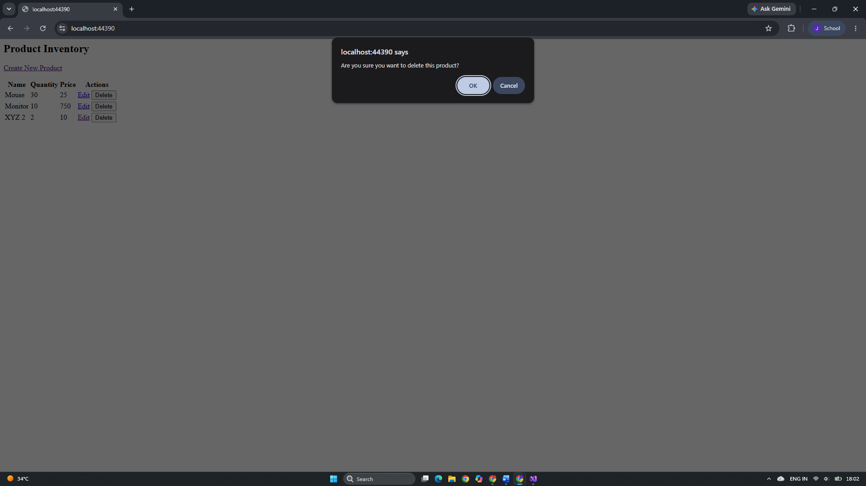
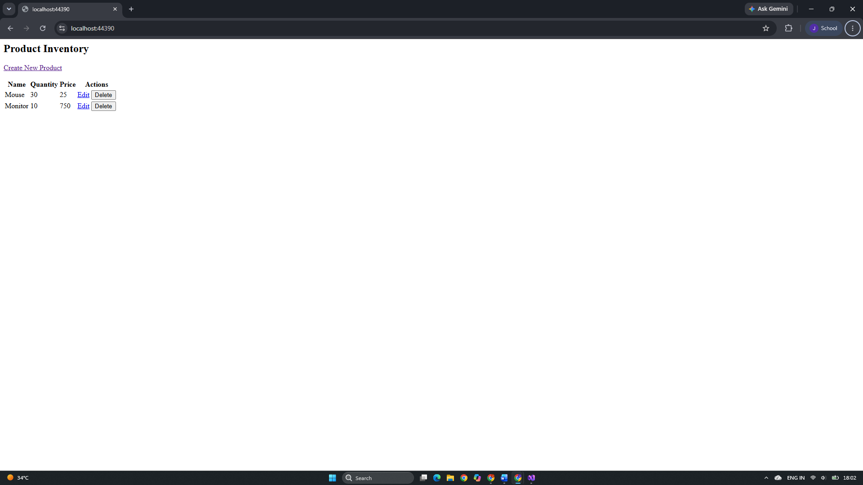

Github Url:
https://github.com/jd-thakrar/Uni-DotNet-Work/tree/master/connecting_sql/connecting_sql

